Say Hello to Your Happy Life!
November 10, 2014 1 Comment Edit
Say Hello to your Happy life because the truth is that happiness can be found within YOU.
As Buddha said “happiness does not depend on what you have or who you are, it solely relies on what You THink!
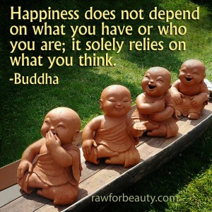
In my personal experience, I Found
Happiness by:
- Making peace with My Past
- Appreciating My Present
- Looking Forward to My Future
In the next blog, I will share with you my journey on HOW I was able to use my Mind in order to:
- Heal myself from painful memories and made peace with my past
- Live up to my true potential by appreciating what I have now
- Awaken my dreams to visualize and look forward to the bright future that awaits me
Stay with me in this journey, together as we slowly unwrap our Presents for a Happier and more meaningful life.
Prayers and Blessings:)
Wanda
Link
http://www.livetoinspire.info/hello-world/

