**My Badges**

1. Create Optin Page

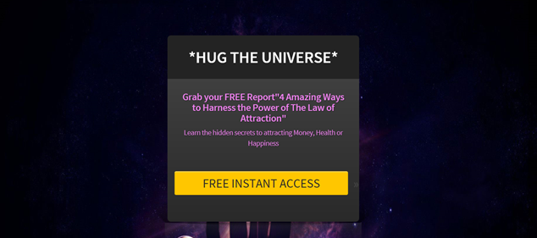

[https://pinnacle101.leadpages.net/powerfulminds/](https://pinnacle101.leadpages.net/powerfulminds/" \t "_blank)

1. Set up Auto responder

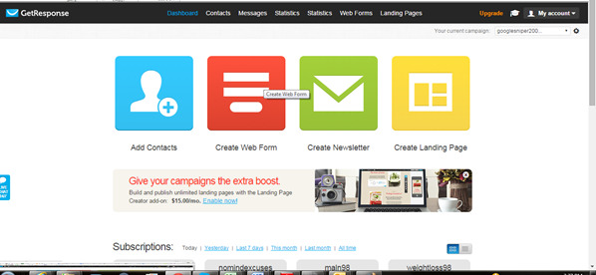

1. Set up 10 day AR series

