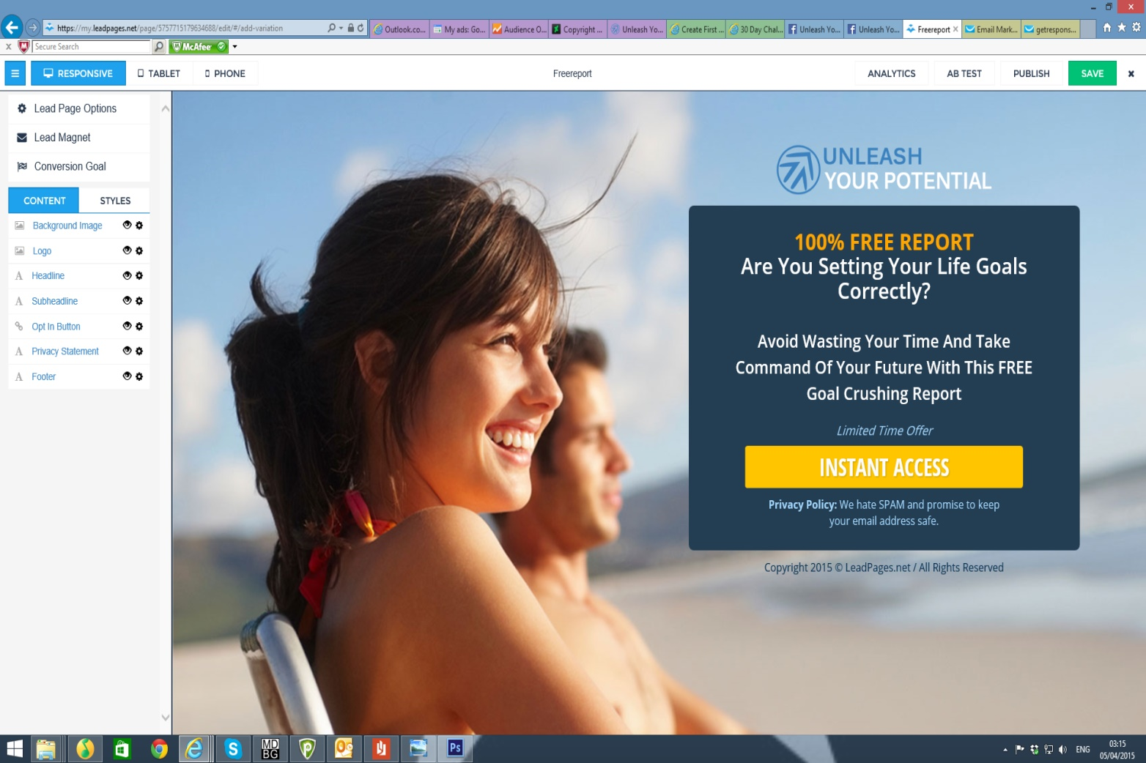**Print Screen of my Opt-in Page by Sean Donovan**