Table of Contents

Submission for 100 Optin’s 1

Submission for Solo Ad 2

# Submission for 100 Optin’s

Hi Team,

I just launched the following Niche and have already got 100 plus people opted in already.

1>Law Of Attraction

2>Meditation

3>Lotus Soul 9 - community

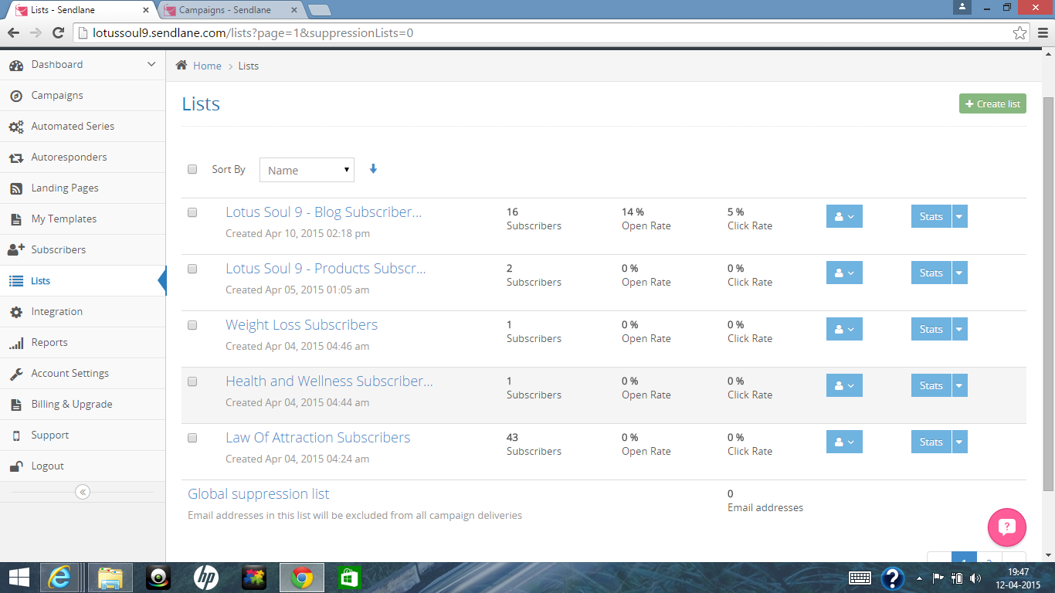

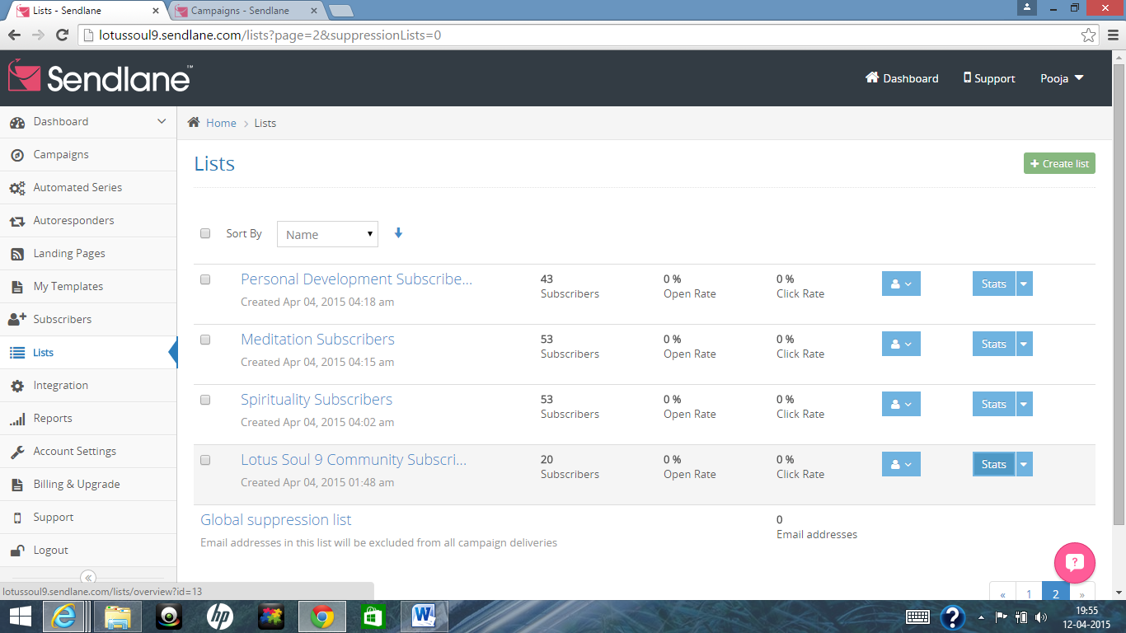

Below is a Clipping of Subscribers list till page 25 ie; 25 pages * 5 subscriber per page = 125 subscribers in few hours…

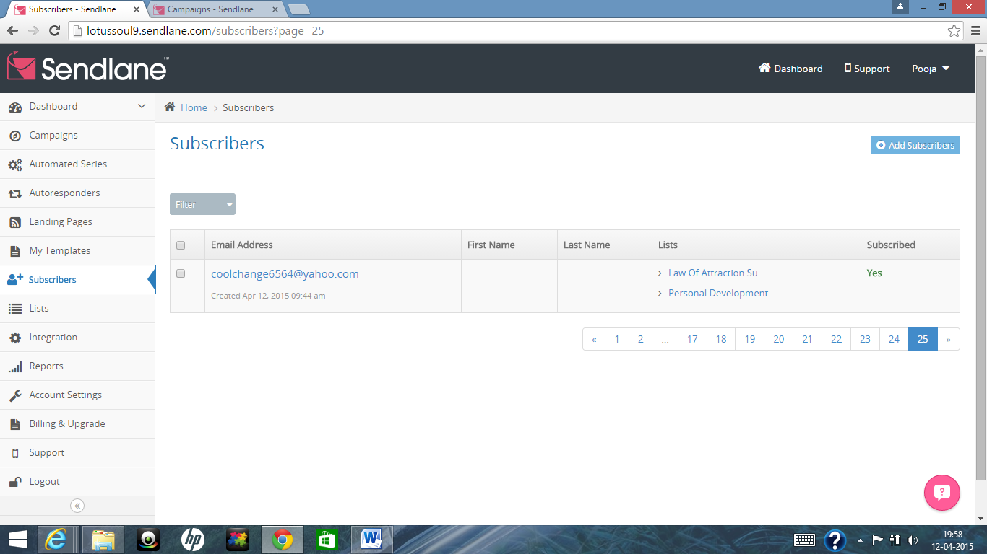

# Submission for Solo Ad

Hi Team,

I achieved the above with a combination of Solo Ads, Facebook and my network.

