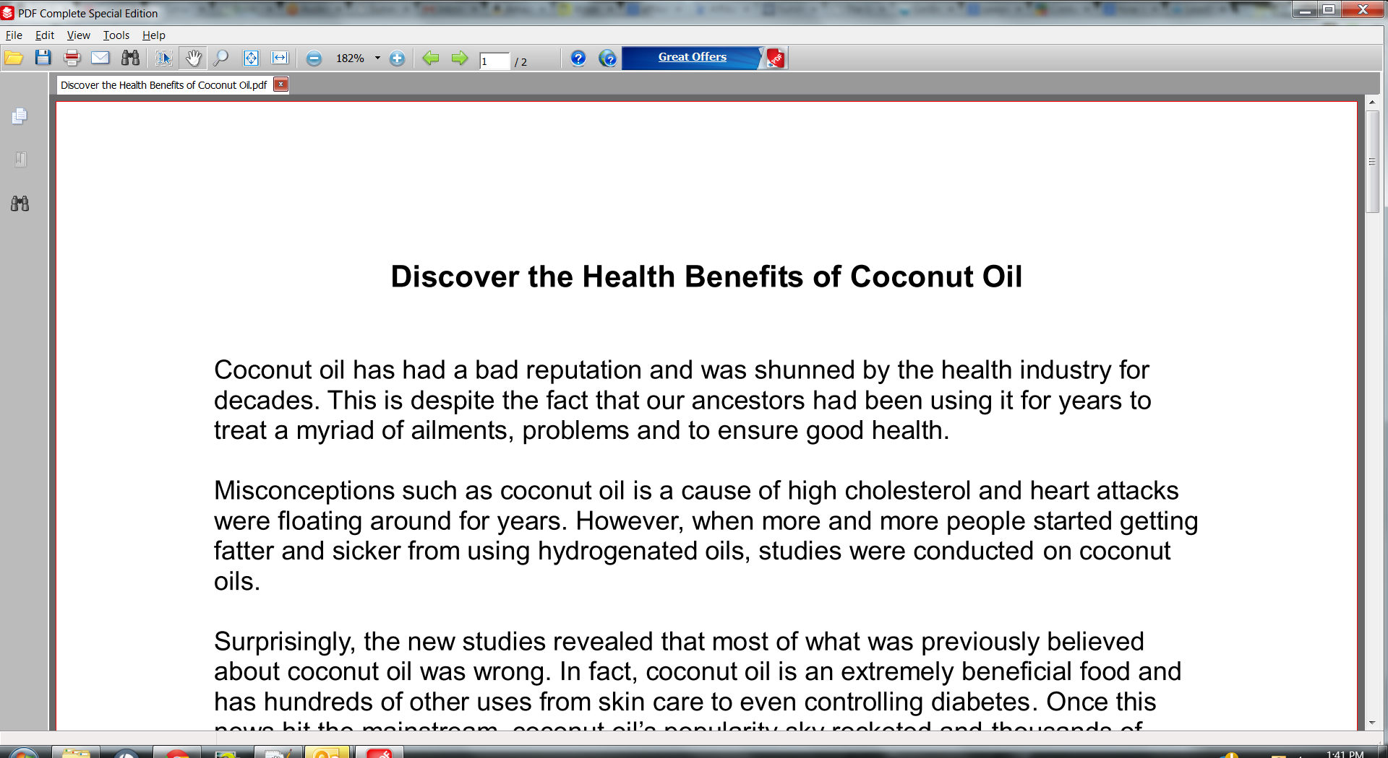

My free gift before I attached it to my first email on Send Lane!