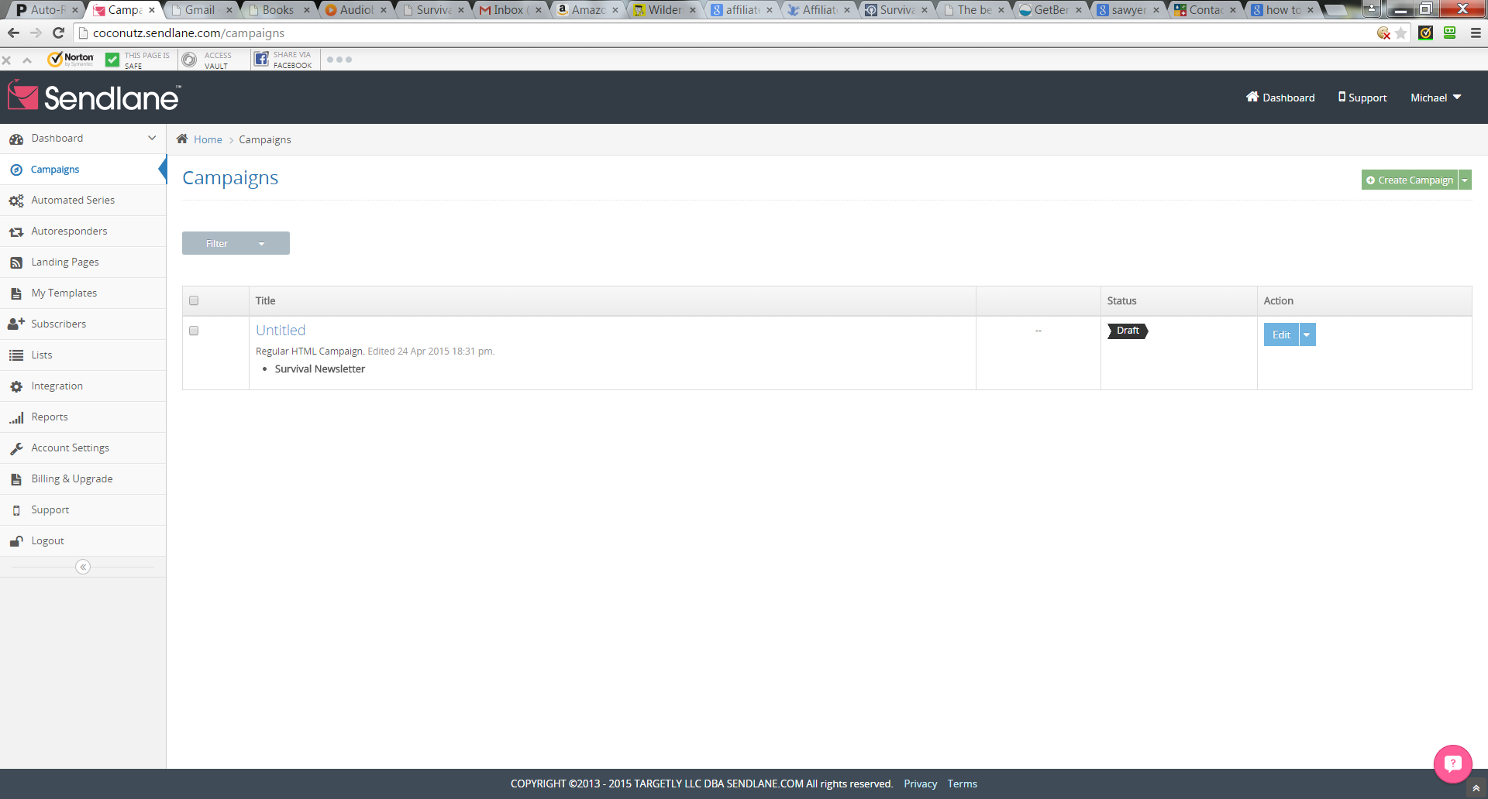

My url: <http://coconutz.sendlane.com/campaigns>